**Gateway Configuration Introduction**

**Revision History**

|  |  |  |  |
| --- | --- | --- | --- |
| **Version** | **Date** | **Change Description** | **Author** |
| V1.0 | 2018/7/1 | initial | Ning |
|  |  |  |  |
|  |  |  |  |
|  |  |  |  |
|  |  |  |  |
|  |  |  |  |
|  |  |  |  |
|  |  |  |  |

**Catalogue**

1. Purpose 3

2. Introduction 3

3. External interface 4

3.1 Network interface 4

3.2 Power supply interface 4

3.3 LED indicator 4

4. Configuration 5

4.1 User name and password 5

4.2 Configuration 5

4.2.1 Network Architecture 6

4.2.2 Connect to the Gateway 6

4.2.1 Configure LAN interface 8

4.2.2 Configure WAN interface 9

4.2.1 Hidden the WAN name 9

4.2.2 Configuring Service Information 10

4.2.3 Modifying the Web Portoal Login Password 11

4.3 Trouble shooting 12

4.3.1 The Gateway flash red LED 12

# Purpose

This document describes the basic functions and physical interfaces of the Gateway, which are mainly used to guide users to install and configure.

# Introduction

The Gateway is made of PC material and is waterproof and dustproof. It supports outdoor installation and can be installed by wall mounting.

After the Gateway power on, it will Periodicly scanning the ESL advertisment pakcet then report the data through WiFi or Ethernet. Also it can accept data command from the cloud and forward the data to ESL, such as updating the ESL configruation. The Gateway using open MQTT + JSON API interface for third-party integration.

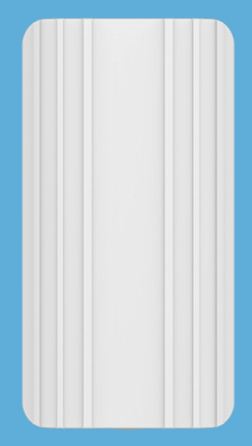 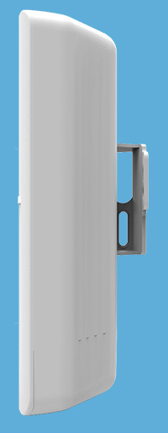

Specification

|  |  |
| --- | --- |
| Power | POE or DC 5V |
| Scanning ability | > 200 beacon per 5 seconds |
| Wireless distance | BLE5.0: > 200 meters  BLE4.0/4.1/4.2 > 100 meters  (depends on environment) |
| BLE | MAX TX power: 5dBm  Receiver Sensitivity: –97 dBm  Protocol:BLE4.0/4.1/4.2/5.0  Antenna: omnidirectional  Antenna VSWR: < 1.3 |
| Transmitting way | * ETH RJ45 * WiFi * WiFi hoppen * USB (For 3G/4G dongle) |
| API protocol | * MQTT |
| Installation way | Screw |
| Waterproof/Dustproof | IP54 |
| Size | 173*90*40 |
| Material | ABS |

# External interface

## Network interface

The Gateway supports following ways to connect to the internet:

1. through WiFi;

2.through the Ethernet interface;

3.throght 2G/3G/4G USB dongle (USB interface has been reserved, but need user to develop USB dongle driver)

4. The Gateway support WiFi Hopping, it means One Gateway can connect to internet by another Gateway.

## Power supply interface

There are two interfaces for power supply: macro USB interface and Ethernet POE port;

* POE power supply, directly through the ethernet cable interface, using POE(802.3af) to supply power.
* Macro USB power supply, powered by the 5V/1A DC.

**Warning: The Gateway can only use one of the two power supplies at the same time. Please don’t insert two power supply at the same time, otherwise Gateway may be damaged.**

## LED indicator

The gateway has 2 LED indicators. The specific meanings are as follows:

**1. Red indicator light:**

If the red led flash, it means the gateway connect to the cloud fails.

**2. Green indicator light:**

* 2-seconds or less frequency flash: indicates that the Gateway is successfully connected to the cloud and report ESL advertisment packet success.
* 10-second frequency flash: indicating that the KGateay connect to the cloud success, but it not found any ESL device.

# Configuration

## User name and password

* After power on, the Gateway will automatic broadcasting Wifi signal, and the default WiFi name is “blegw_mac address”

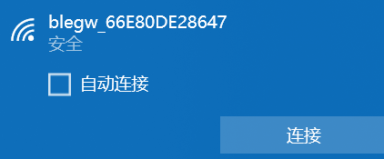

* The default WiFi connection password is“12345678”
* The default Gateway configruation IP address is 192.168.8.1
* The default web portal login name is“root”, and the default password is also“root”

## Configuration

The Gateway is configured in web portal mode. You can using an web broswer to configure it. To ensure security, the configuration protocol uses https.It is recommended to use the chrome browser for configuration.

### Network Architecture

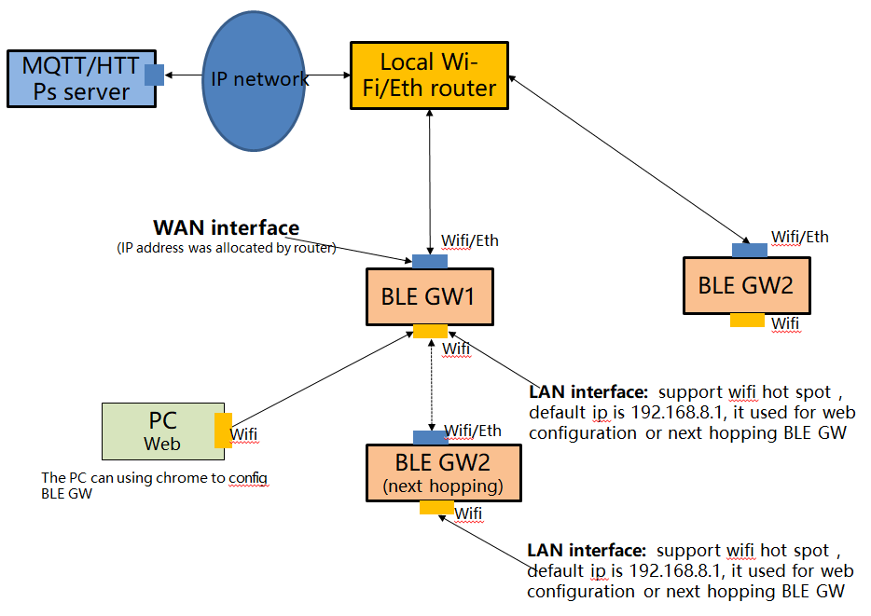

As shown above, each base station has two interfaces with different IP addresses. One of these IP addresses (referred to as the WAN port) is used to connect to the internet network (MQTT server), which has a series of firewall rule protection. Another IP address (referred to as LAN port, also known as the intranet interface) is used for Wifi hotspot broadcasting.

**WAN Port:** This interface supports WiFI and ETH (network wire). Gateway can connect to routers via WiFi or network wire, where IP addresses are assigned by routers. The base station is connected to the MQTT server through this interface, so you need to ensure that the network between this interface and the MQTT server is interconnected. WAN address IP address configuration see "4.3.2 configuration WAN port network connection".

**LAN port:** This interface only supports WIFI. The default IP address of this interface is 192.168.8.1, PC can connect to this interface through WIFI, or the next hopping Gateway can connect to the internet by Upper level.

If you need to configure the gateway, you can only configure it through WiFi, and you can not configure it through the network line (for security reasons, the network line interface only supports the WAN interface).

### Connect to the Gateway

1. Power on the Gateway.

2. Using you PC with WiFi function to scan the WiFi signal of Gateway. If the device name is as follows, it indicates that it is an Gateway.



3. Input the WiFi password. The default is 12345678.

4. Log in to the gateway by typing https://192.168.8.1 in the browser. Due to the HTTPs login, the browser will pop up a warning. Click on "Advanced" and then click on "Continue to 192.168.8.1" to enter the login page.

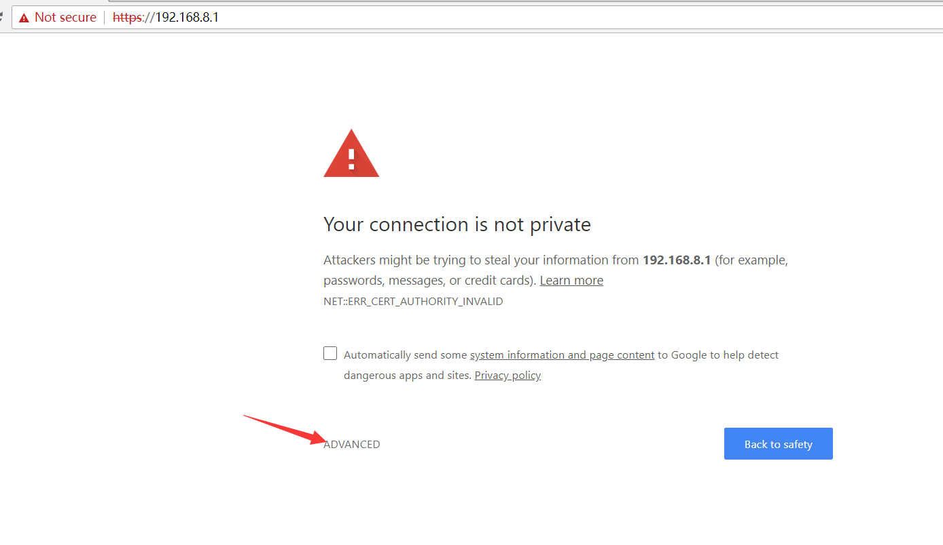

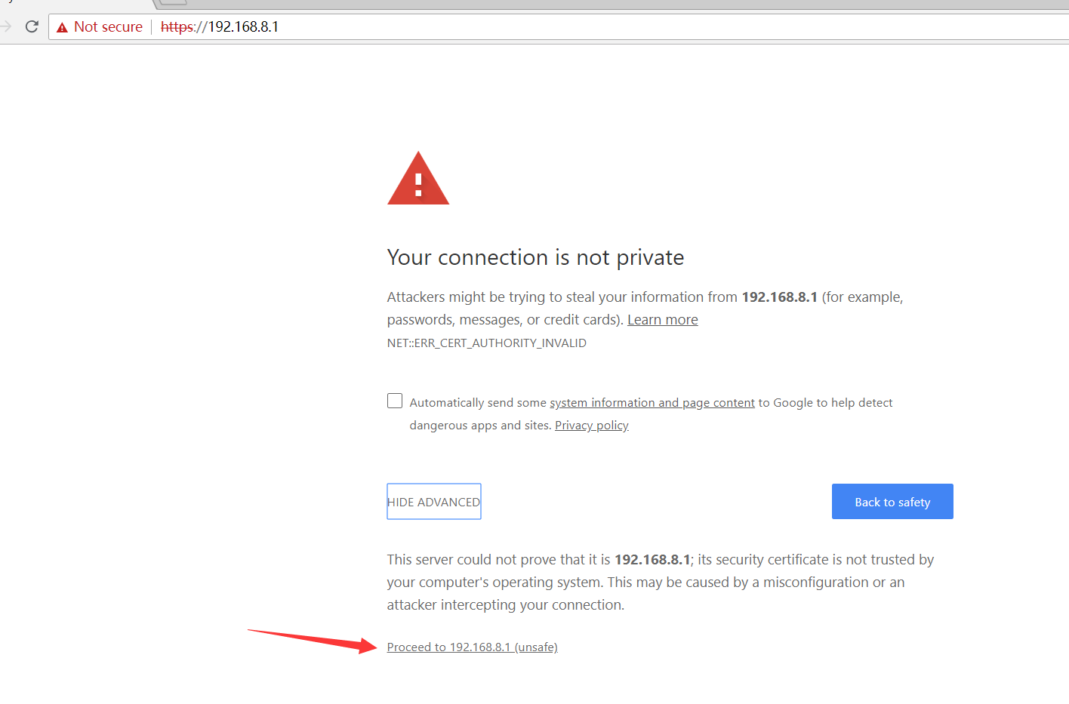

5. Enter the user name: root and password: root

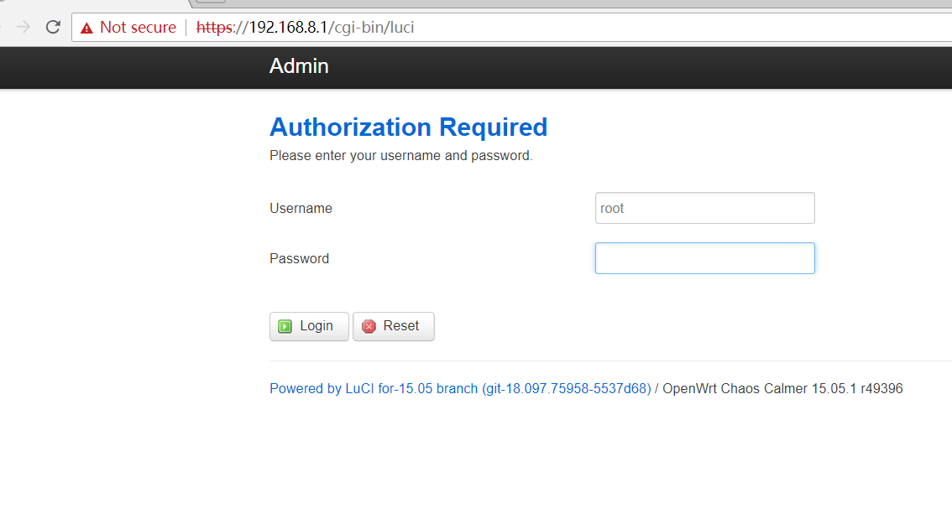

### Configure LAN interface

Check status about Gateway, you can change the LAN IP address.

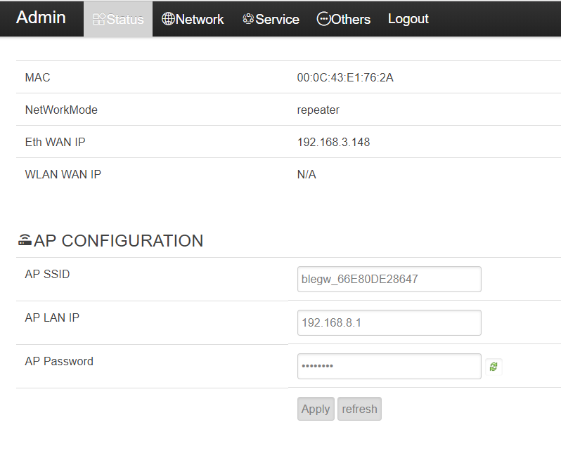

### Configure WAN interface

Tap on ***Network*** to go to the network configuration page. You can choose to connect to the network using WiFi or Ethernet connection.

The IP address can be assigned in DHCP or static configuration.

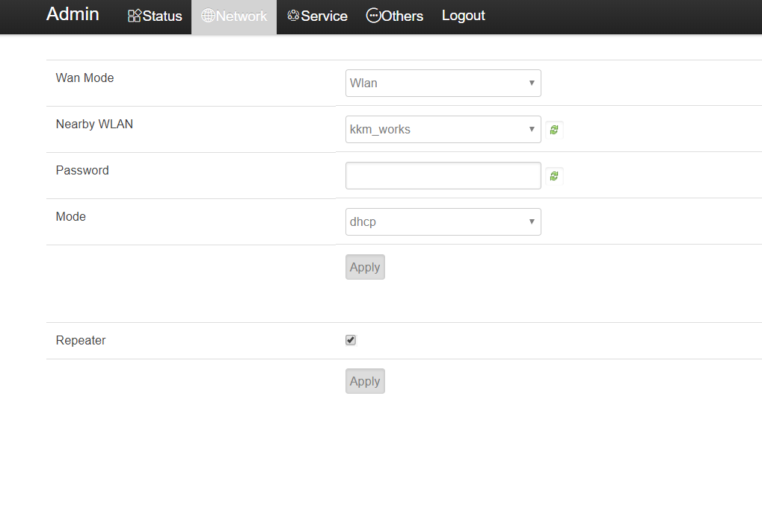

### Hidden the WAN name

For some security reason, we may need to hidde the wifi name.

If the Repeater was not selected, then the wifi name will be hidden. You will found an hidden wifi. The default wifi ssid is blegw_DXXXXXXXXXXX. Please make sure the lowcase and capcase. DXXXXXXXXXXX is the mac address about the Gateway, you can found the mac address on the shell. The default password is “12345678”.

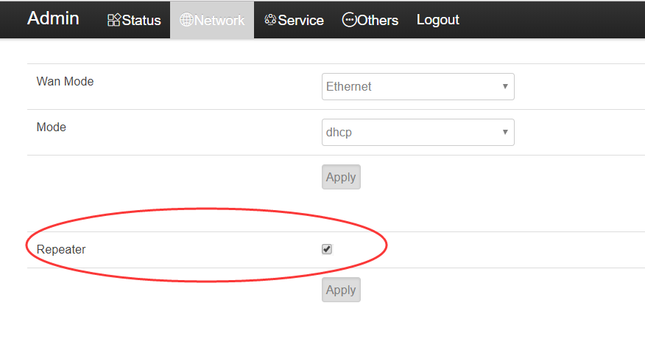

### Configuring Service Information

Click Services to go to the service configuration page, where each field is defined as follows:

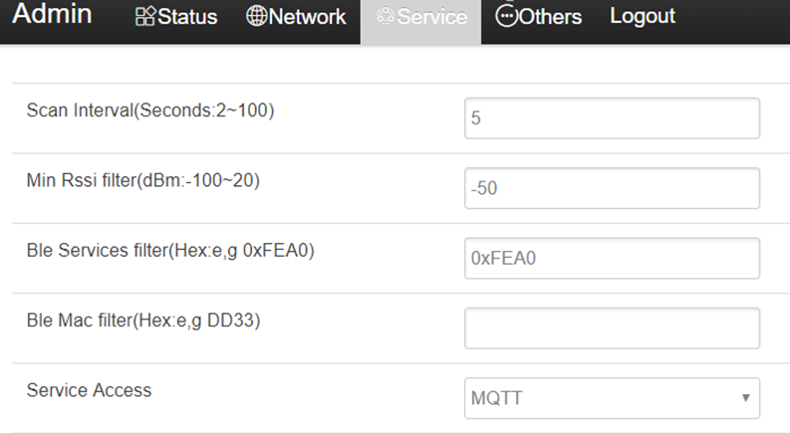

**1. Scan Interval:** This paramaters used for filter same Beacon report advertisment packet multi-time. the broadcast message of the same ESL will only be reported to MQTT server once in one **Scan interval**.

**2. Min Rssi filter:** If this paramaters was set, the Gateway will only report the advertisement packet which signal > **Min Rssi** value.

**3. Ble Services filter:** must be fixed to 0xFEA0

**4. Ble Mac filter:** If this paramaters was set, the Gateway will only report the Beacon advertisement packet which mac address include the filter value.

For example, if Ble Mac filter value set to 33DD, then following ESL advertisement packet will report to cloud.

* ESL1: mac = 0x33DD01000002
* ESL2: mac = 0xA133DD010002
* ESL3: mac = 0xA10005033DD2

5. **Service Access:** must be fixed to MQTT

**6. MQTT configuration**

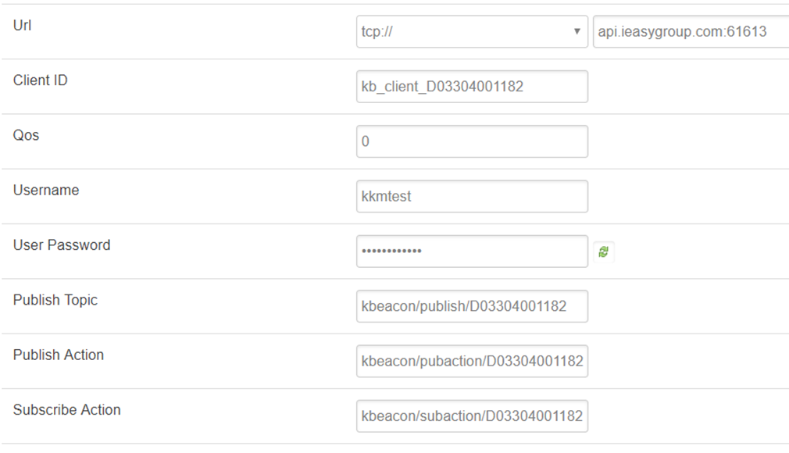

* **Url:** MQTT server address and port
* **Client ID:** Mqtt client id
* **Qos:** MQTT qos value for publish action and subscribe action topic. The publish Topic Qos is fixed to 0.
* **Username:** mqtt client user name
* **User Password**: mqtt client password
* **Publish Topic:** The status of the status release message, the status of the gateway scanning to each label, published through this topic.
* **Publish Action:** The response message of the gateway to the MQTT server, such as pictures and new response messages, is published through this topic.
* **Subscribe Action:** The gateway store will subscribe to the request from the MQTT server to listen to this topic. Such as pictures with new request messages.

Other MQTT parameters are basic MQTT information, which will not be detailed here.

### Modifying the Web Portoal Login Password

The login password defaults to “root” and the user can change it to another password.

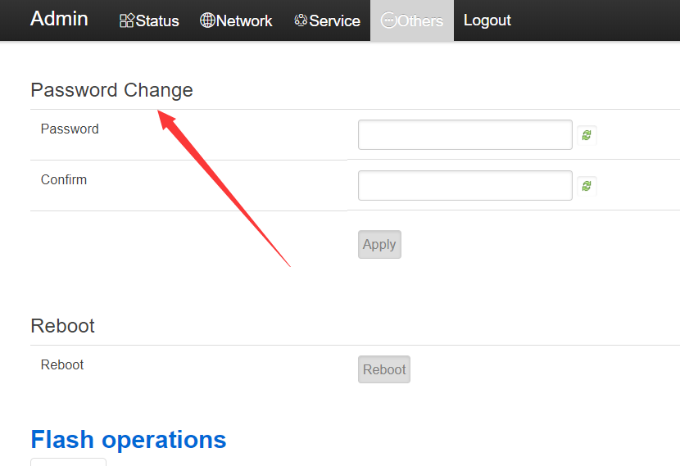

## Trouble shooting

### The Gateway flash red LED

If the Gateway connect to MQTT server success, it will flash green LED, otherwiseit will flash red LED.

If the Gateway flash red led, please check the connection by following steps:

#### Check the connection between Gateway and cloud server

**Scenario 1: The Gateway and Server are deployed in the same LAN**

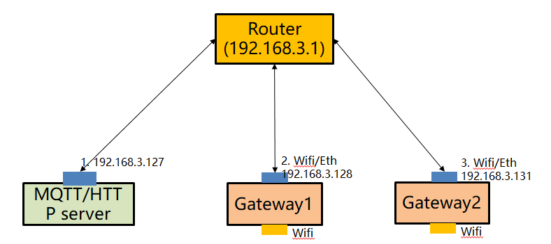

It is necessary to ensure that the base station and server are in the same network, that is, the assigned IP address is in the same network. For example, if the IP address of the MQTT server is 192.168.3.127, the base station 1 can be configured as the following address(192.168.3.128).

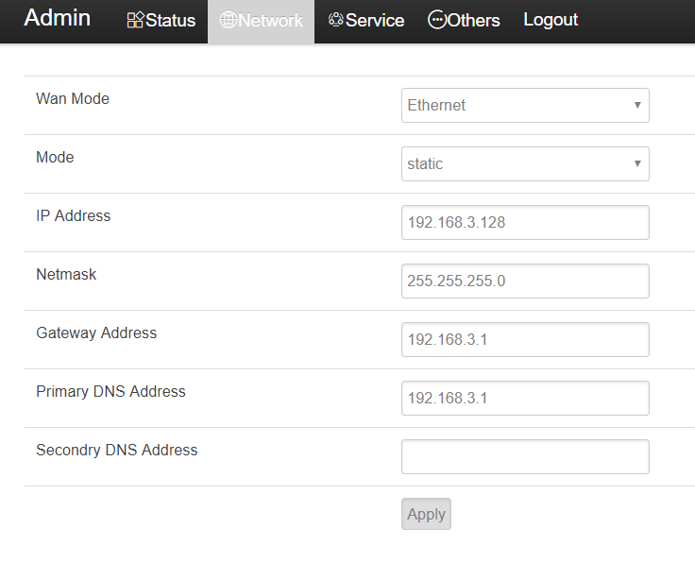

Try to using PING command detection Gateway on MQTT server. The PING command is used to detect whether the base station and the MQTT server network are connected. If the ping failed, please check whether the connection is normal.

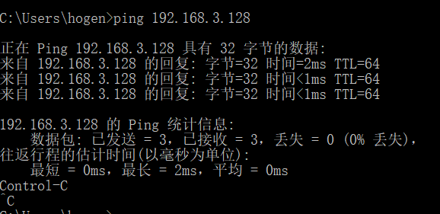

**Scenario two: the Servers are deployed in the cloud**

We provide an free MQTT test server. Please try to use MQTT test server to verify if Gateway connect to cloud success. We provide a cloud-based test server with the IP address of the MQTT server: api.ieasygroup.com; it support both MQTT. The Gateway has been set up as the Mqtt test server by default.

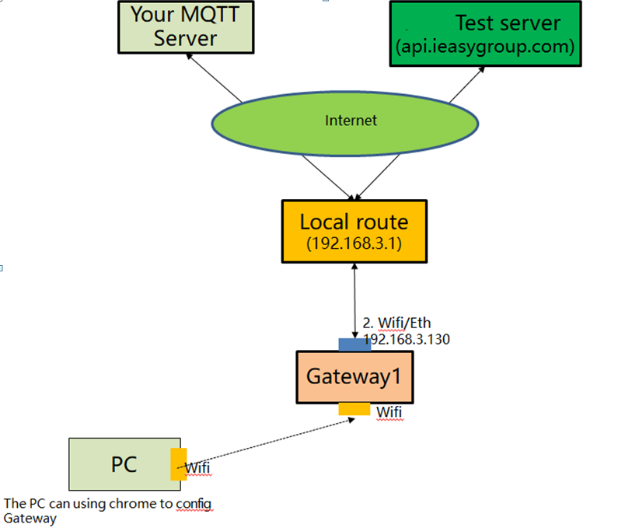

Assuming that the IP address of the router is 192.168.3.1, the IP address of the base station can be configured as 192.168.3.128.

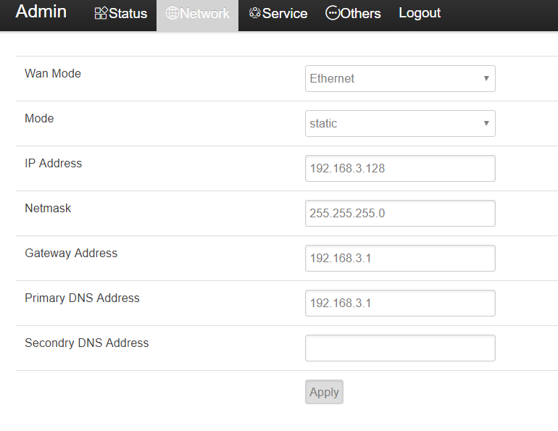

KKM MQTT server information：

* Address: api.ieasygroup.com:61613
* Test user name: kkmtest
* password: testpassword

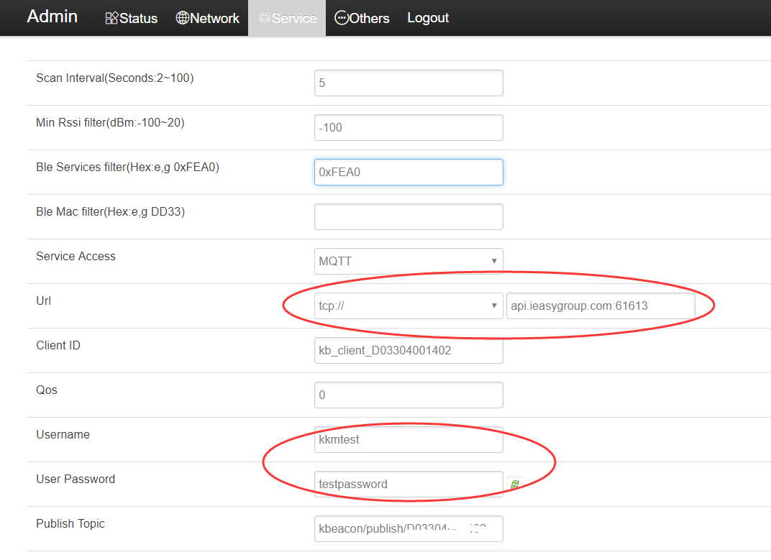

Wait 30 seconds to 1 minute after saving the settings. If the base station flashes green light, the network connection between the base station and the cloud is normal. If it still flash red LED, the network connection between Gateway and the Cloud maybe failed.

#### Check if the MQTT server running normal

Please referance section 7.2 Using third part MQTT client to verify Gateway in <<Gateway API Introduction>> document.

If MQTT client connection fails, please check:

1) is there a firewall on the MQTT server to prevent other client connections? The default port of the MQTT server is 61613.

2) whether the MQTT server is installed correctly.